

**Informatics Institute of Technology**

**Department of Computing**

**(B.Eng.) in Software Engineering**

Module: Database Systems

5COSC008C

**Database Systems Coursework (2020/2021)**

# Coursework Part A and Coursework Part B

## Part A Project: FOODTOOYOU

**Part B Project Brief: Futuro**

**Date of Submission: 07/12/2020**

Module Leader – Mr. Ragu Sivaraman

Name : Oshadha Malith Goonathilake

UoW ID - w1762649

Student ID - 2018402

Group - E

Table of Contents

Coursework Part A and Coursework Part B 1

Part A Project: FOODTOOYOU 1

Introduction 3

Part A : FOODTOOYOU 4

Produce a complete CONCEPTUAL 4

ERD for FOODTOOYOU. 4

2) Create a data dictionary to document how you identified the entities for FOODTOOYOU. 6

3) Create a data dictionary to document how you identified the relationships and multiplicities for FOODTOOYOU. 8

4) Create a data dictionary to document how you identified the attributes and primary keys for each entity for FOODTOOYOU. 12

Part B : FUTURO 18

Produce a complete LOGICAL 18

ERD for FUTURO. 18

Provide a step-by-step guide explaining how you produced the Futuro logical ERD i.e. how you mapped the Futuro conceptual ERD into a full logical relational schema. 20

7) Write some SQL code to create the Company, Staff and Offer tables in the MySQL RDBMS. Also insert 3 records in the Company table, 4 records in the Staff table and 5 records in the Offer table. 24

Create Tables 24

Insert values into Tables 30

8) Write a SQL query to retrieve a list of company codes and company names and for each company the number of staff that they employ, making sure that the header shows the number of employees in each company as “Number of staff”. 36

9) Write a SQL query that displays a list of company names along the names and positions of staff they employ and the names and descriptions of the offers they propose. 38

Conclusion 40

References 41

# Introduction

**Part A**

The main idea of doing this coursework is to create a Conceptual ER diagram individually. FOODTOOYOU is a company where delivers grocery items ordered by the registered members of the company from registered retailing stores. It will be delivered on the same day or on the following day. The idea was initiated during the COVID-19 lockdown that was put in UK from March to June 2020 when access to the groceries become challenging.

Part A first question (**1**) is to create a database architecture to undertake a database project to support the needs of the company. It needs to include all the entities, relationships, multiplicities, attributes and primary keys that has been identified

Part A second question (**2**) is to create a data dictionaryto document how the entities have been identified for FOODTOOYOU.

Part A third question (**3**) is to create a data dictionary to document how the relationshipsand multiplicities are identified for FOODTOOYOU.

Part A last question (**4**) is to create a data dictionary to document how the attributesand primary keysfor each entity have been identified for FOODTOOYOU.

**Part B**

Futuro is the careers and professional development service offered by the University of Westminster where the Futuro employs several career consultants to provide guidance and advice to the students who use the service to find employment opportunities. Many Companies gives offers which the students are interested. To assist the students with their applications, career consultants at Futuro where it organise support sessions to help them with their application forms, CVs and cover letters. Futuro career consultants also organise a number of events to showcase jobs and graduate schemes.

Part B first question (**5**) is to design a complete LOGICAL ERD for Futuro which should contain relationships, multiplicity constraints, attributes, primary keys and foreign keys.

Part B second question (**6**) is to give a step by step guide how the logical ERD is mapped in numbered bullet points which should fit to maximum of three pages.

Part B third question (**7**) is to create the Company, Staff and Offer tables in the MySQL RDBMS. Also insert 3 records in the Company table, 4 records in the Staff table and 5 records in the Offer table including screen shots of the codes and the outputs.

Part B fourth question (**8**) is to write SQL queries to retrieve a list of company codes and company names and for each company the number of staff that they employ.

Part B last question (**9**) is to write SQL queries that display a list of company names along the names and positions of staff they employ and the names and descriptions of the offers they propose.

# Part A : FOODTOOYOU

# Produce a complete CONCEPTUAL

# ERD for FOODTOOYOU.

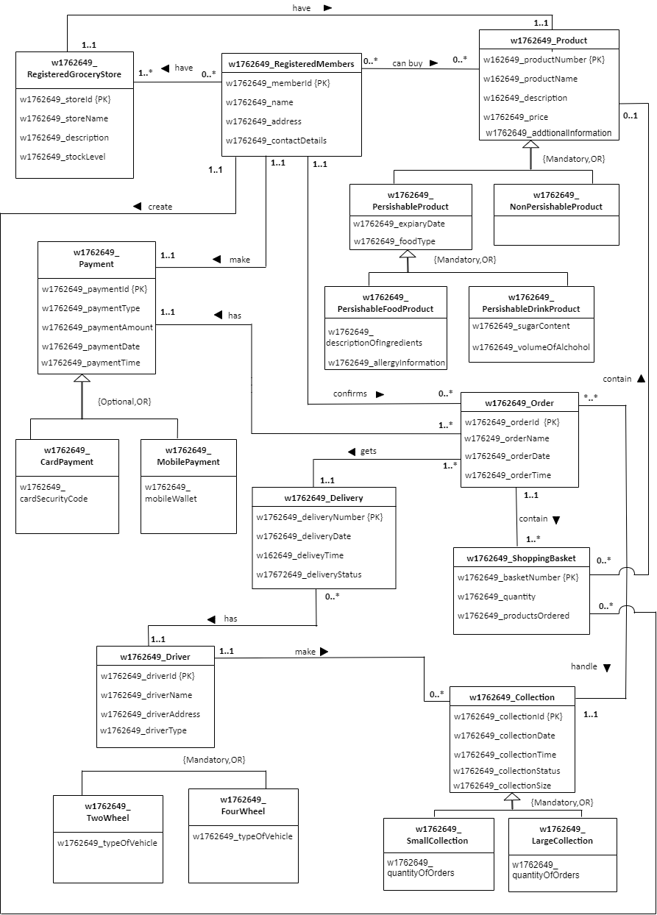

# Create a data dictionary to document how you identified the entities for FOODTOOYOU.

|  |  |
| --- | --- |
| *Entity name* | *Description* |
| w1762649_RegisteredGroceryStore | General term describing all the grocery stores in the FOODTOOYOU where the registered members buy their products. |
| w1762649_RegisteredMembers | General term describing all the registered members in the FOODTOOYOU who buy products from the grocery stores, who confirm orders and make payments. |
| w1762649_Product | General term describing all the products including perishable products and non-perishable products. Perishable products contain two types as perishable food products and perishable drink products in the grocery stores of FOODOOYOU where the registered members can access and put to the shopping baskets. |
| w1762649_Payment | General term describing the payments including card payments and mobile payments done by the registered members of FOODTOOYOU for their orders. |
| w1762649_Order | General term describing all the orders ordered by the registered members of FOODTOOYOU which makes a collection. |
| w1762649_ShoppingBasket | General term describing all the shopping baskets which are contained in an order owned by the registered members of FOODTOOYOU. |
| w1762649_Collection | General term describing all the collections including small collections and large collections which are formed by all the orders altogether which are done by the drivers of FOODTOOYOU and where the products ordered by the registered members contain. |
| w1762649_Delivery | General term describing all the deliveries of the orders, done by the drivers of FOODTOOYOU. |
| w1762649_Driver | General term describing all the drivers in FOODTOOYOU who delivers orders to the houses of the registered members and who do the collections in FOODTOOYOU. Drivers include two-wheel drivers and four-wheel drivers. |

|  |  |  |
| --- | --- | --- |
| *General entity* | *Specialized entity* | *Explanation* |
| w1762649_Product | w1762649_PerishableProduct | Product can be divided into two as perishable and non-perishable. Products must be either perishable or Non-Perishable products.  In the coursework specification it has mentioned that most products are perishable products.  Other than perishable products there are non-perishable products where the coursework specification mentioned that not all products are perishable. |
| w1762649_NonPerishableProduct |
| w1762649_PerishableProduct | w1762649_PerishableFoodProduct | Perishable Products must be either divided as food products or drink products.  Food products and Drink products are identified as perishable products because they have attributes that a perishable product should have. |
| w1762649_PerishableDrinkProduct |
| w1762649_Payment | w1762649_CardPayment | Payments can be either done by card or by mobile. Those are the main types of payments that FOODTOOYOU accept. Other than the main types of payments there can be payments through cash also. |
| w1762649_MobilePayment |
| w1762649_Driver | w1762649_FourWheel | Drivers must use either four wheel or two wheel vehicles for their delivery services in FOODTOOYOU where there are no other vehicle types in FOODTOOYOU. |
| w1762649_TwoWheel |
| w1762649_Collection | w1762649_SmallCollection | Collections are varying size as small collection and large collection in FOODTOOYOU delivery service. Collection must be divided as either small or large. By dividing the collection as large and small it is easy to track and manage the collection process. |
| w1762649_LargerCollection |

# Create a data dictionary to document how you identified the relationships and multiplicities for FOODTOOYOU.

|  |  |  |  |  |  |
| --- | --- | --- | --- | --- | --- |
| *Entity name* | *Multiplicity* | *Relationship* | *Multiplicity* | *Entity name* | *Justifications for the multiplicity*  *(4 statements for each relationship)* |
| w1762649_  RegisteredGroceryStore | 1..* | have | 0..* | w1762649_  RegisteredMembers | One registered grocery store may not have any registered member. |
| One registered grocery store may have maximum of many registered members. |
| One registered member may have minimum of one registered grocery store. |
| One registered member may have maximum of many registered grocery stores. |
| w1762649_  RegisteredGroceryStore | 1..1 | has | 1..1 | w1762649_Poduct | One registered grocery store has at least of one unique product. |
| One registered grocery store has a maximum of one unique product. |
| One Product may have a minimum of one registered grocery store. |
| One product may have maximum of one registered grocery store. |
| w1762649_  RegisteredMembers | 0..* | can buy | 0..* | w1762649_Product | One registered member may not buy any product. |
| One registered member can buy maximum of many number of products. |
| One product may not be bought by any registered member. |
| One product can be bought by maximum of many registered members. |

|  |  |  |  |  |  |
| --- | --- | --- | --- | --- | --- |
| *Entity name* | *Multiplicity* | *Relationship* | *Multiplicity* | *Entity name* | *Justifications for the multiplicity*  *(4 statements for each relationship)* |
| w1762649_  RegisteredMembers | 1..1 | create | 0..* | w1762649_  ShoppingBasket | One registered member may not create any shopping basket. |
| One registered member create maximum of many shopping baskets.(Members have to create separate shopping baskets for each grocery store) |
| One shopping basket is created by minimum of one registered member. |
| One shopping basket is created by maximum of one registered member. |
| w1762649_  ShoppingBasket | 0..* | contain | 0..1 | w1762649_  Product | One shopping basket may not contain any product. |
| One shopping basket contain maximum of one product (As products are unique to each store and registered members have to create separate shopping baskets to every store.) |
| One Product may not be contained in any shopping basket. (Because members may not put any product into a shopping basket.) |
| One product is contained in maximum of many shopping baskets. |
| w1762649_  RegisteredMember | 1..1 | confirms | 0..* | w1762649_Order | One registered member may not confirm any order. |
| One registered member may confirm maximum of many orders. |
| One order is confirmed by at least one registered member. |
| One order is confirmed by maximum of one registered member. |
| *Entity name* | *Multiplicity* | *Relationship* | *Multiplicity* | *Entity name* | *Justifications for the multiplicity*  *(4 statements for each relationship)* |
| w1762649_Order | 1..* | has | 1..1 | w1762649_  Payment | One order has a minimum of one payment. |
| One order has maximum of one payment. |
| One payment is had by a minimum of one order. |
| One payment is had by maximum of many orders. |
| w1762649_  Order | 1..1 | contain | 1..* | w1762649_  ShoppingBasket | One order contains a minimum of one shopping basket. |
| One Order contains a maximum of many shopping baskets. |
| One shopping basket is contained in at least of one order. |
| One shopping basket is contained in maximum of one order. |
| w1762649_Order | 1..* | gets | 1..1 | w1762649_  Delivery | One order gets minimum of one delivery. |
| One order gets maximum of one delivery. |
| One delivery has a minimum of one order. |
| One delivery has a maximum of many orders. |
| w1762649_  Collection | 1..1 | handle | *..* | w1762649_Order | One collection is handled by minimum of many orders. |
| One collection is handled by maximum of many orders. |
| One order handles minimum of one collection. |
| One order handles maximum of one collection. |
| w1762649_Delivery | 0..* | has | 1..1 | w1762649_Driver | One delivery has a minimum of one driver. |
| One delivery has a maximum of one driver. |
| One driver may not have any deliveries. |
| One driver may have maximum of many deliveries. |
| *Entity name* | *Multiplicity* | *Relationship* | *Multiplicity* | *Entity name* | *Justifications for the multiplicity*  *(4 statements for each relationship)* |
| w1762649_Driver | 1..1 | make | 0..* | w1762649_-Collection | One driver may not make any collections. |
| One driver make maximum of many collections. |
| One Collection is made by at least one driver. |
| One collection is made by maximum of one driver. |

# Create a data dictionary to document how you identified the attributes and primary keys for each entity for FOODTOOYOU.

|  |  |  |
| --- | --- | --- |
| *Entity name* | *Attributes for this entity (include PK)* | *Justification* |
| w1762649_  RegisteredGroceryStore | w1762649_storeId {PK} | **storeID** is recognized as a primary key because each store can be uniquely identified.  **storeName** is used to store the name of each Store, **decription** stores the information of each store while the **stockLevel** stores the level of stock to maintain the stocks easily. |
| w1762649_storeName |
| w1762649_description |
| w1762649_stockLevel |
| w1762649_  RegisteredMembers | w1762649_memberId {PK} | **memberID** is unique to each registered member because it is necessary when the member visits to buy products.  **name** attribute is used to store the name of each member, **address** stores the address of each member which helps when delivering the orders and the **contactDetails** store the telephone numbers etc. where the member can be contacted. |
| w1762649_name |
| w1762649_address |
| w1762649_contactDetails |
| *Entity name* | *Attributes for this entity (include PK)* | *Justification* |
| w1762649_Product | w1762649_productNumber {PK} | **productNumber** is use to identify each product uniquely when billing and buying products.(Helpful in member side and from the shop side.)  **productName** is used to save the name of each product, **description** attribute is used to store the product information, **price** attribute is used store the prices of each product.  **aditionalInformation** attribute is used to give some additional information such as discounts etc. |
| w1762649_productName |
| w1762649_description |
| w1762649_price |
| W1762649_additionalInformation |
| w1762649_PerishableProduct | w1762649_expiaryDate | **(expiaryDate** attribute stores the date of expiry of perishable products.  **foodType** attribute stores the type of perishable food. Example: Biscuit, Soft drinks) Useful for the members who buy the product. |
| w1762649_foodType |
| w1762649_PerishableFoodProduct | w1762649_descriptionOfIngredients | **(descriptionOfIngredients** stores the information of the ingredients which made up that product.  **allergyInformation** attribute saves about the information, that if there is an allergy containing ingredients in the particular product) Useful for the members who buy the product. |
| W1762649_allergyInformation |
| w1762649_PerishableDrinkProduct | w1762649_sugarContent | **sugarContent** stores the amount of sugar included in that particular drink product.  **volumeOfAlchohol** saves the information of the alcoholic percentage of that particular drink product. |
| w1762649_volumeOfAlchohol |
| *Entity name* | *Attributes for this entity (include PK)* | *Justification* |
| w1762649_Payment | w1762649_paymentId {PK} | **paymentID** is uniquely identified and it is useful when a member pay their amount and when in any case of trouble regarding the payment.  **paymentType** is used to store the type of payment namely card payment, mobile payment.  **paymentAmount** is used to store the amount paid by the member, **paymentDate** and **paymentTime** is used store date and time of the payment is done and to make convenient o the member. |
| w1762649_paymentType |
| w1762649_paymentAmount |
| w1762649_paymentDate |
| w1762649_paymentTime |
| w1762649_CardPayment | w1762649_cardSecurityCode | **cardSecurityCode** stores the security code of a card either credit or debit card. |
| w176264_MobilePayment | w176264_mobileWallet | **mobileWallet** stores the information about the payments which are done through the mobile device. |
| w1762649_Order | w1762649_orderId {PK} | **orderID** is use to identify each order uniquely and orderID is very useful when delivering the products and when doing collections.  **orderName** saves the name of each order, **orderDate** and **orderTime** stores the date and time of the order, which is confirmed and to make convenient to the member. |
| w1762649_orderName |
| w1762649_orderDate |
| w1762649_orderTime |
| *Entity name* | *Attributes for this entity (include PK)* | *Justification* |
| w1762649_ShoppingBasket | w1762649_basketNumber {PK} | **basketNumber** is uniquely identified because it is very useful when billing and when putting products to the basket by the member.  **quantity** stores the amount of products included in a basket and **productsOrdered** attribute store the names of each products in the shopping basket. |
| w1762649_quantity |
| w1762649_productsOrdered |
| w1762649_Collection | w1762649_collectionId {PK} | **collectionID** is identified as a primary key because each collection can be uniquely identified and it is very useful when doing collection by the drivers.  **CollectionDate** and **collectionTime** is used make an accuracy when doing collection(date and time that collection is done) and **collectionStatus** stores the status of the collection as pending, confirmed, in process, delivered, etc.  **collectionSize** saves the information of the size of the collection whether it is small or large. |
| w1762649_collectionDate |
| w1762649_collectionTime |
| w1762649_collectionStatus |
| w1762649_collectionSize |
| w1762649_SmallCollection | w1762649_quantityOfOrders | As mentioned in the coursework specification collection is divided into small and large. To identify a collection as a small collection there should be an amount that shows the quantity of orders should be contained in small collection should end.(Ex: Small collection –> 1-10 orders)  **quantityOfOrders** stores the quantity of orders that contained in small collection. |
| *Entity name* | *Attributes for this entity (include PK)* | *Justification* |
| w1762649_LargeCollection | w1762649_quantityOfOrders | As mentioned in the coursework specification collection is divided into small and large. To identify a collection as a large collection there should be an amount that shows the quantity of orders should be contained in large collection. .(Ex: Large collection –> upward 10)  **quantityOfOrders** stores the quantity of orders that contained in large collection. |
| w1762649_Delivery | w1762649_deliveryNumber {PK} | **deliveryNumber** is uniquely identified because it is useful for the member who request a delivery as well as for the company side.  **deliveryDate** and **deliveryTime** stores the date and time of the delivery and **deliveryStatus** stores the status of the delivery as pending, confirmed, in process or delivered. |
| w1762649_deliveryDate |
| w1762649_deliveryTime |
| w1762649_deliveryStatus |
| w1762649_Driver | w1762649_driverId {PK} | **driverID** is identified as a primary key because driver can be uniquely identified.  **driverName** stores the name of the drivers of FOODTOOYOU, **driverAddress** stores the address of each driver while **driverType** saves the type of the driver whether the driver is four wheel driver or two wheel driver. |
| w1762649_driverName |
| w1762649_driverAddress |
| w1762649_driverType |
| *Entity name* | *Attributes for this entity (include PK)* | *Justification* |
| w1762649_TwoWheel | w1762649_typeOfVehicle | **typeOfVehicle** stores the information of the vehicle type whether it is a bike or moped when considering two wheel drivers. |
| w1762649_FourWheel | w1762649_typeOfVehicle | **typeOfVehicle** stores the information of the vehicle type whether it is a car or van when considering four wheel drivers. |

# Part B : FUTURO

**5)**

# Produce a complete LOGICAL

# ERD for FUTURO.

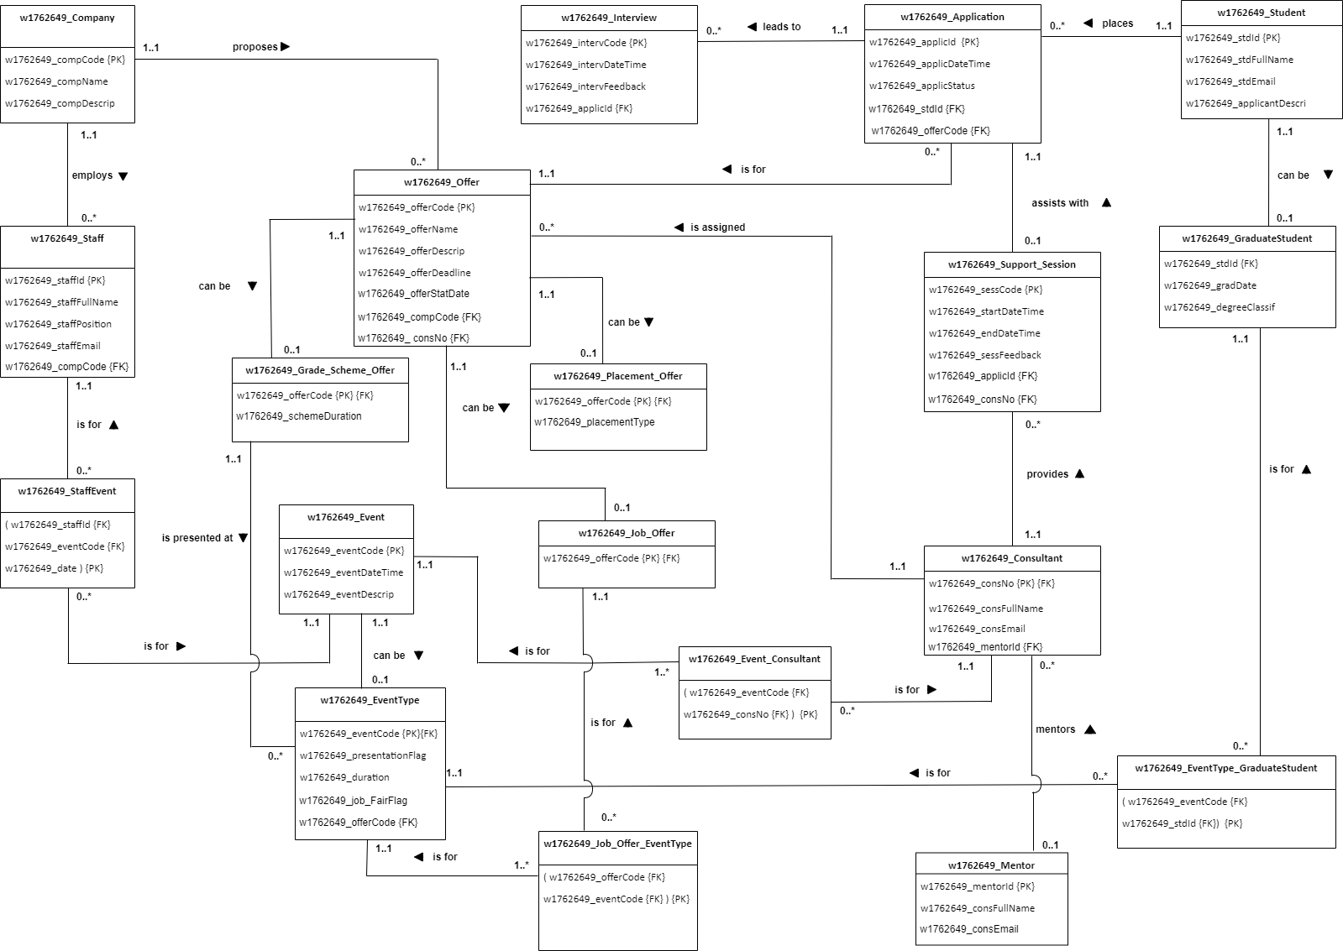

**6)**

# Provide a step-by-step guide explaining how you produced the Futuro logical ERD i.e. how you mapped the Futuro conceptual ERD into a full logical relational schema.

**Step 1**

**1.1 1) 1.** Event can be broken down into a child class name EventType.

**2.** Primary key of parent class Event is added into the subclass EventType as a primary key and a foreign key.

**3.** Flags and the attributes of the two sub entities Presentation and Job_Fair is added to the child class EventType.

1. One Event cannot have any Event Type and one Event can be maximum of one EventType.

**5.** One EventType may have minimum and maximum of one EventType.

**2) 1.** Offer can be divide into three child classes as Grad_Sheme_Offer,Job_Offer and Placement_Offer.

**2.** The primary key of the parent class offer is added to the three child classes as a foreign key and as a primary key.

**3.** One offer can’t have any Grad_Sheme_Offer,Job_Offer , Placement_Offer and Offer can have maximum of one Grad_Sheme,Job_Offer and a Placement_Offer.

1. One Grad_Sheme_Offer, Job_Offer and Placement_Offer can have minimum and maximum of one offer.

**3) 1**. Student can be breakdown into a child class as Graduate_Student, as the {optional} participation is taken as {optional,OR},because there is only one child class, so it should definitely participate as there are no other child classes . (In {optional,OR} there is a comparison between child classes and one should definitely participate ).

**2**. Primary key of Student is added to the Graduate_Student as a primary key and a foreign key, while all the attributes of Graduate is added to the newly created child class Graduate_Student.

**3**. One Student cannot have any Graduate_Student and can have maximum of one Graduate_Student.

**4**. One Graduate_Student can have minimum and maximum of one Student.

**Step 2**

**2.2 1) 1**. Staff and Event Parent Classes are connected for one child class named Staff_Event as it

has many to many relationships.

**2.** Staff_Event sub entity if for Staff and Event parent classes.

1. Primary keys of Staff and Event Parent classes are added to the Staff_Event child class as a foreign key and date is taken as a primary key.
2. Staff and Event may not have any Staff_Event and have maximum of many Staff_Event.
3. Staff_Event child class has minimum and maximum of one Staff and one Event parent classes.

**2) 1**. Job and Event_Type are connected to one child class namely Job_EventType as it has many to many relationships.

**2.**  Job_EventType child class is for Job and EventType parent classes.

**3.**  Primary keys of Job and EventType is added to the Job_EventType child class as primary and foreign keys.

1. One job many not have any Job_EventType and have maximum of many EventTypes.

**5**. One EventType is for minimum of one Job_EventType and maximum of many Job_EventTypes.

1. One Job_EventType have minimum and maximum of one Job and one EventType.

**3) 1**. Event and consultant parent classes are connected to one child class name Event_Consultant as it has many to many relationships.

**2**. Event_Consultant child class is for Event and Consultant parent classes.

**3**. Primary keys of Event and Consultant are added to the Event_Consultant as foreign and primary keys.

**4**. One Event has minimum of one Event_Consultant an maximum of many Event_Consultants.  **5.** One Consultant may not have any Event_Consultant and have maximum of many Event_Consultants.

**6.** One Event_Consultant has minimum and maximum of one Event and one Consultant parent classes.

**4) 1**. EventType and GraduateStudent parent classes are connected to one child entity namely EventType_GraduateStudent, as it has many to many relationships.

**2.** EventType_GraduateStudent is for EventType and GraduateStudent parent classes.

**3**. Primary keys of EventType and GraduateStudent parent classes are added as foreign and primary keys to EventType_GraduateStudent.

**4.** EventType and GraduatStudent may not have any EventType_GraduateStudent and have maximum of many EventType_GraduateStudent.

**5**. One EventType_GraduateStudent is for minimum and maximum of one EventType and one GraduateStudent parent classes.

**Step 3**

**3.1 1) 1**.Application entity and Support_Session entities do not connect with a new child entity

as it has one to one relationship optional on one side.

**2.** Primary key of the Application is added to the Support_Session entity as a foreign key.

**3**. Application may not have any Support_Session and have maximum of one Support_Session.

**4**. One Support_Session assists with one and only one Application.

**3.2 1) 1**. Company and Staff entities do not connect with a new child entity as it has one to many relationships.

**2**. Primary key of Company is added to the Staff entity as a foreign key.

**3**. Company may not employ any Staff and employ maximum of many Staffs.

**4**. One Staff has one and only one company.

**2) 1**. Interview and Application entities do not connect with a new child entity as it has one to many relationships.

**2**. Primary key of Application is added to the Interview entity as a foreign key.

**3**. One Interview has one and only one Application.

**4**. One Application may not lead to any Interview and leads to maximum of many Interviews.

**3) 1**. Company and Offer entities do not connect with a new child entity as it has one to many relationship.

**2**. Primary key of Company is added to the Offer entity as a foreign key.

**3**. One Company may not propose any Offer and proposes many Offers.

**4**. One Offer has one and only one Company.

**4) 1**.Application and Student entities do not connect with any child entity as it has one to many relationships.

**2**. Primary key of Student entity is added to the Application entity as a foreign key.

**3**. One Application has one and only one Student.

**4**. One Student may not place any Application and places maximum of many Applications.

**5) 1**.Offer and Application entities do not connect with any new child entity as it has one to many relationships.

**2**. Primary key of Offer entity is added to the Application entity as a foreign key.

**3**. One Offer may not have any application and have maximum of many Applications.

**4**. One Application is for one and only one Offer.

**6) 1**.Support_Session and Consultant entities do not connect with any new child entity as it has one to many relationships.

**2**. Primary key of Consultant is added to the Support_Session entity as a foreign key.

**3**. One Support_Session has one and only one Consultant.

**4**. One Consultant may not provide any Support_Session and provides maximum of many Support_Sessions.

**7)** **1**. Offer and Consultant entities do not connect with a new child entity as it has one to many relationships.

**2**. Primary key of Consultant is added to the Offer entity as a foreign key.

**3**. One Offer has one and only one Consultant.

**4**. One Consultant may not assign to any Offer and is assigned to many Offers.

**8) 1**. Consultant and Mentor entities do not connect with a new child entity as it has one to many relationships.

**2**. Primary key of Consultant is added to the Consultant itself as a foreign key.

**3**. Foreign Key of Mentors entity is added to the Consultant entity as a foreign key.

**4**. One Consultant may not have any Mentors and have maximum of one Mentor.

**5**. One Mentor may not have any Consultant and have maximum of many Consultants.

**9) 1**.Grad_Sheme_Offer and EventType entities do not connect with a new child event as it has one many relationship.

**2**. Primary key of Grad_Sheme _Offer entity is added to the EventType entity as a foreign key.

**3**. One Grad_Sheme_Offer may not present at any EventType and presents at maximum of many EvenTypes.

**4**. One EventType has one and only one Grad_Sheme_Offer.

# 7) Write some SQL code to create the Company, Staff and Offer tables in the MySQL RDBMS. Also insert 3 records in the Company table, 4 records in the Staff table and 5 records in the Offer table.

## Create Tables

**w1762649_Company**

CREATE TABLE w1762649**_**Company (

w1762649_compCode int(10),

w1762649_compName VARCHAR(10) UNIQUE NOT NULL,

w1762649_compDescrip VARCHAR(60) NOT NULL,

constraint c_compCode_pk PRIMARY KEY (w1762649_compCode)

);

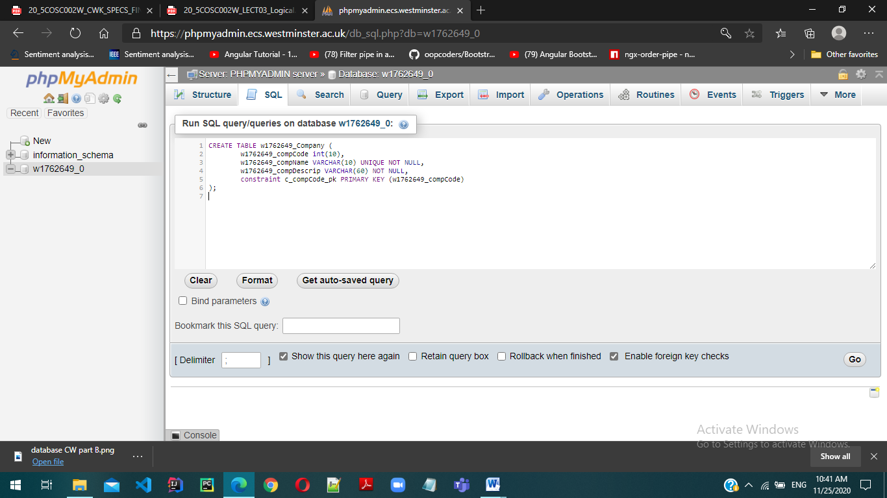

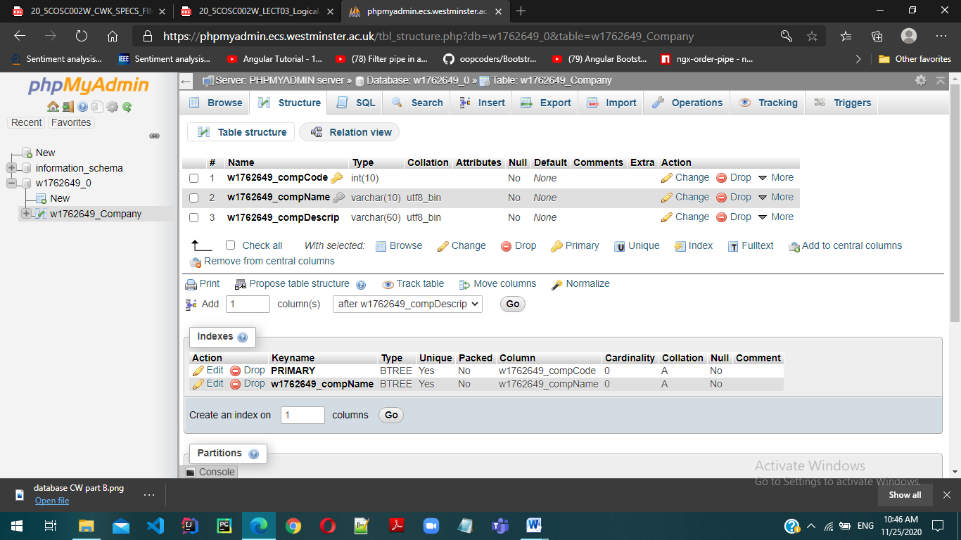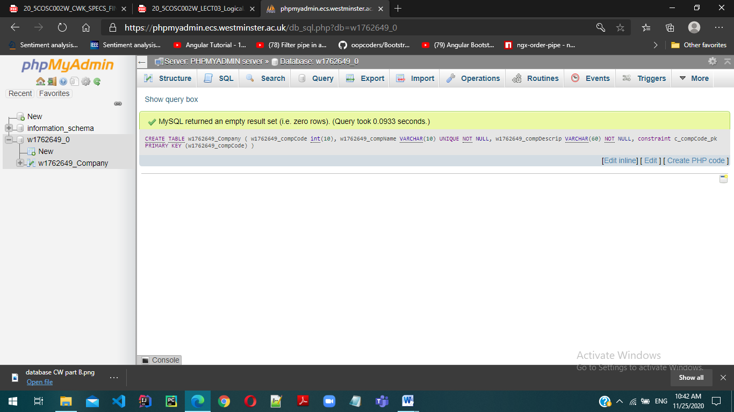

# 

**w1762649_Staff**

CREATE TABLE w1762649**_**Staff (

w1762649_staffId VARCHAR(12),

w1762649_staffFullName VARCHAR(20) UNIQUE NOT NULL,

w1762649_staffPosition VARCHAR(25) NOT NULL,

w1762649_staffEmail VARCHAR(35) NOT NULL,

w1762649_compCode int(10),

constraint s_sid_pk PRIMARY KEY (w1762649_staffId),

constraint c_compCode_fk FOREIGN KEY (w1762649_compCode)

references w1762649_Company (w1762649_compCode)

);

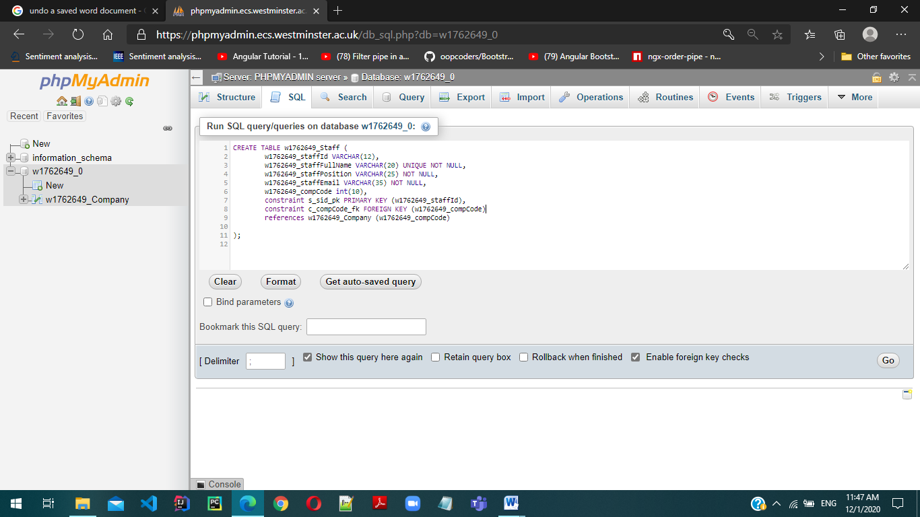

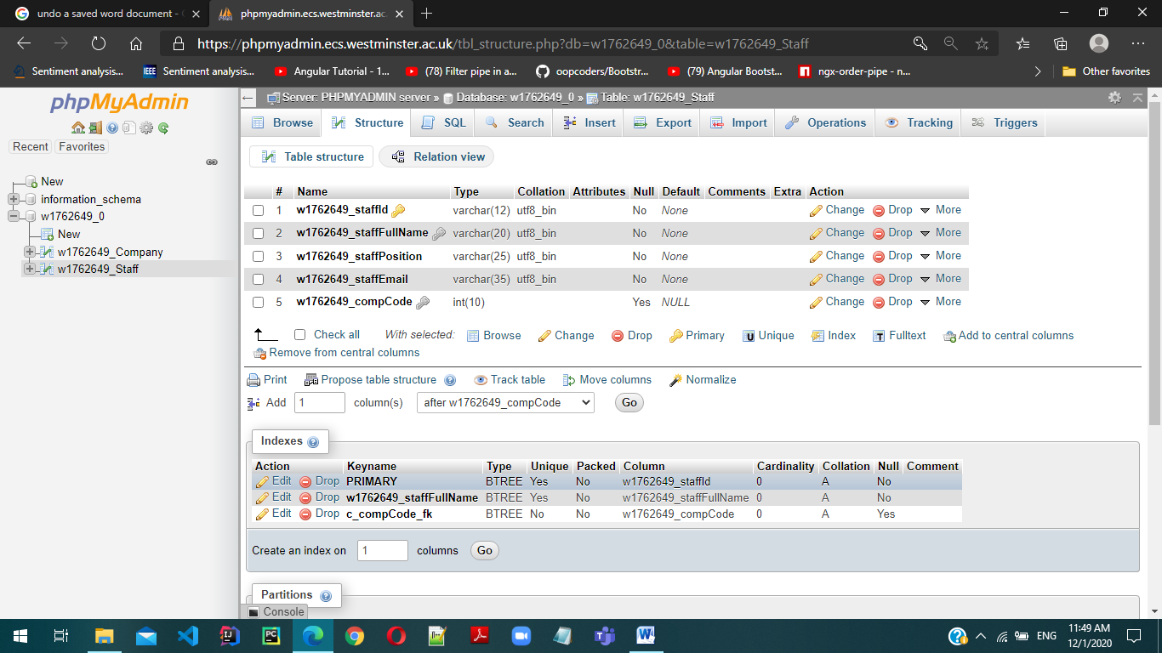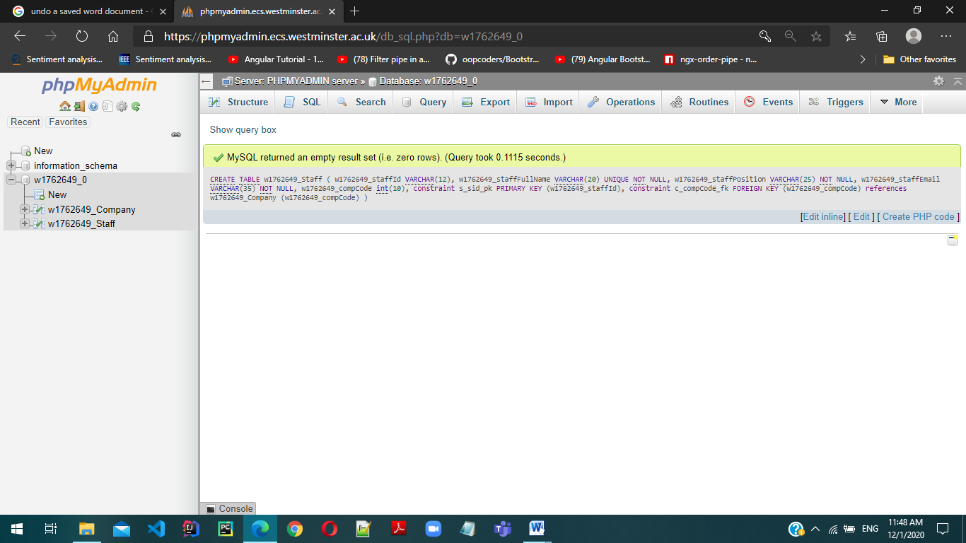

**w1762649_Offer**

CREATE TABLE w1762649_Offer (

w1762649_offerCode int(10),

w1762649_offerName VARCHAR(30) UNIQUE NOT NULL,

w1762649_offerDescrip VARCHAR(150) NOT NULL,

w1762649_offerDeadline DATETIME,

w1762649_offerStartDate DATE,

w1762649_compCode int(10),

constraint o_offercode_pk PRIMARY KEY (w1762649_offerCode),

constraint o_compcode_fk FOREIGN KEY (w1762649_compCode)

references w1762649_Company(w1762649_compCode)

);

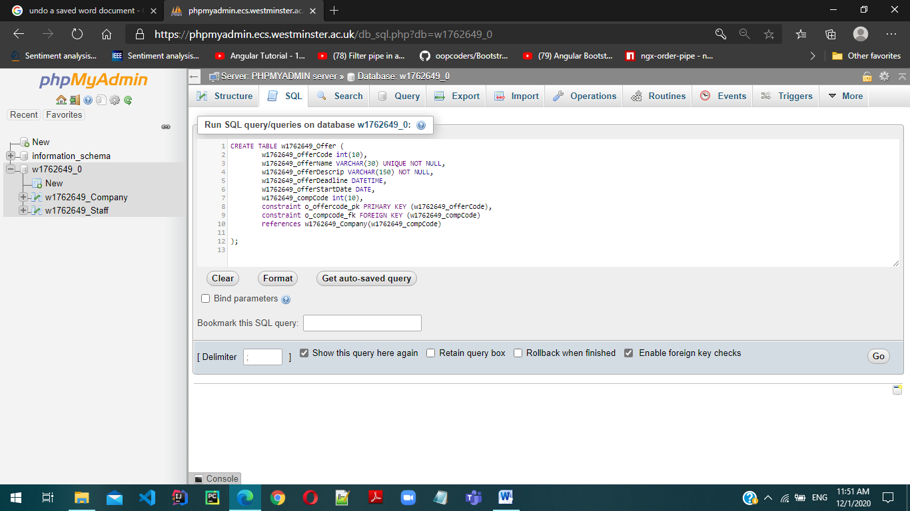

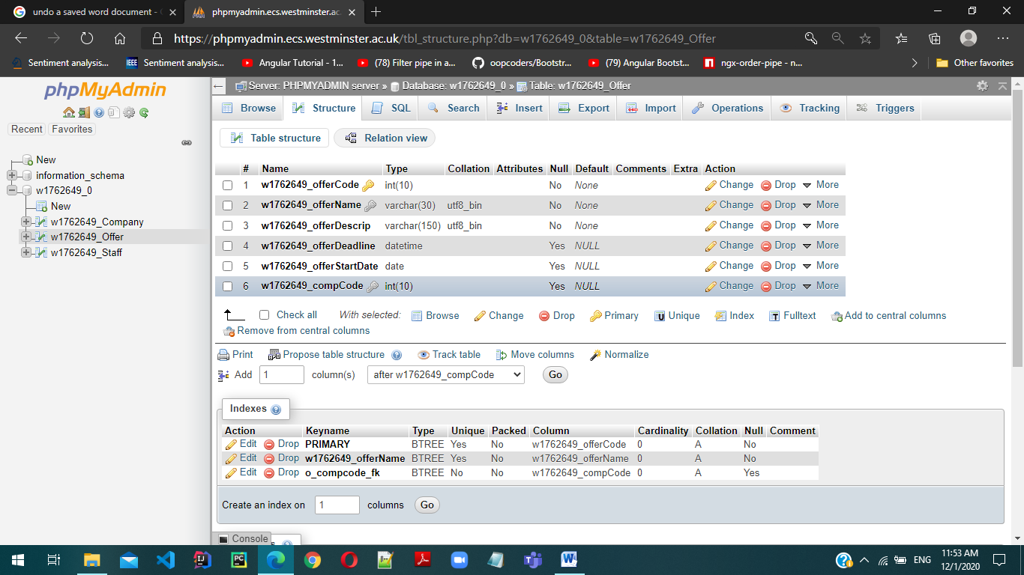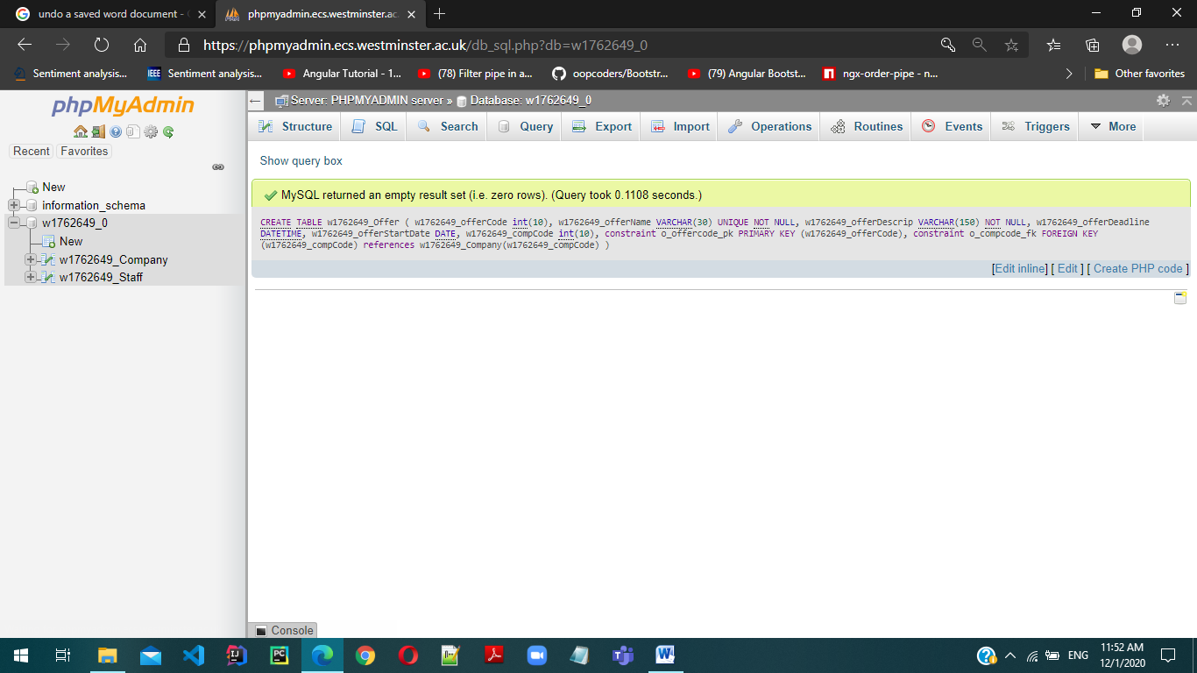

## Insert values into Tables

**w1762649_Company**

INSERT INTO w1762649_Company (w1762649_compCode, w1762649_compName, w1762649_compDescrip) VALUES

(0987654321,"IntelTech","IntelTech is a digital transformation consultancy company."),

(0223415674,"FedEx","FedEx provides Digital business transformation."),

(0648352674,"ComLab", "ComLab provides a full software potential.");

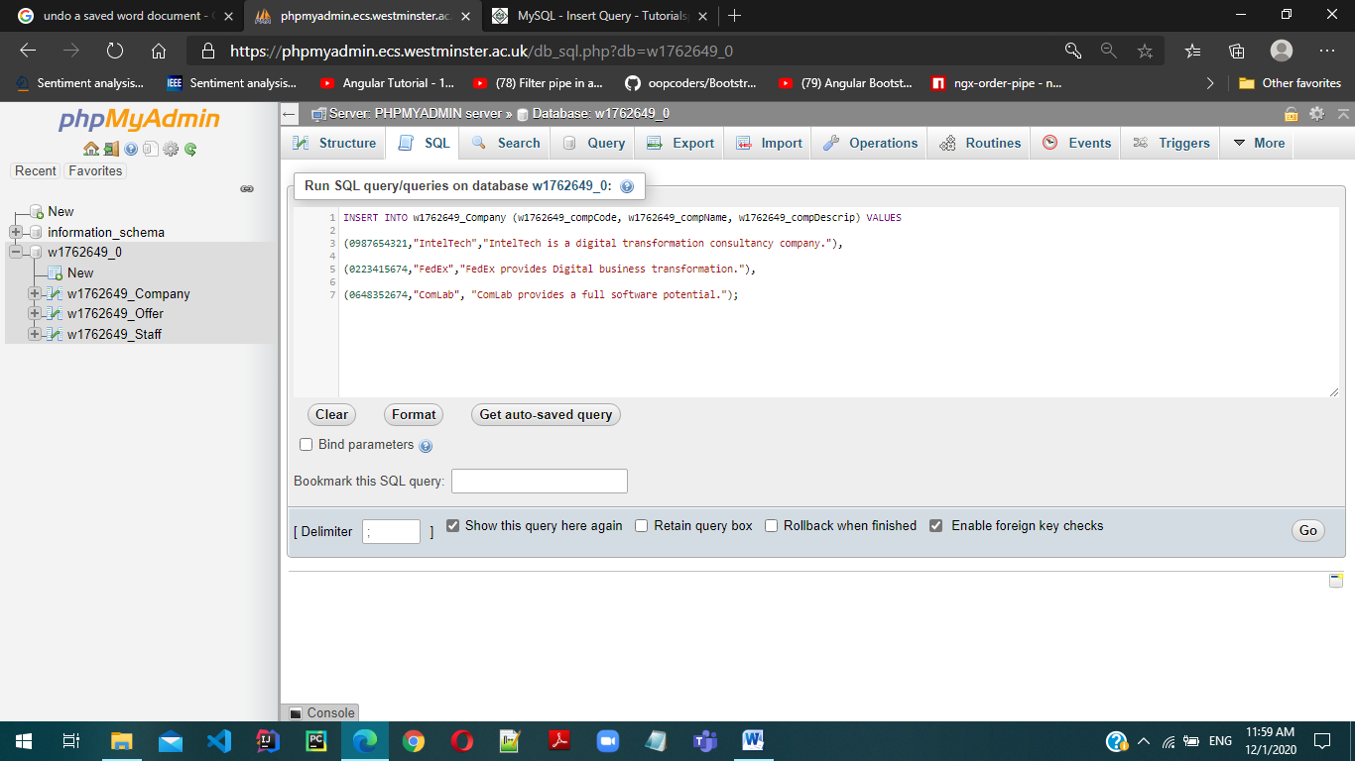

# 

**w1762649_Staff**

INSERT INTO w1762649_Staff (w1762649_StaffId,w1762649_StaffFullName,w1762649_staffPosition,w1762649_staffEmail,w1762649_compCode) VALUES

("S9022415342","Adam Smith", "Marketing Manager","adamsmith4040@gmail.com", 0987654321),

("S9456371342","John Ethan", "Accountant", "johnethan8@hotmail.com",0648352674),

("S9887563863","Ben Strokes", "Software Engineer","strokey123@outlook.com",0223415674),

("S9661423750","Oliver Lewis","Business Administrator","oliverLew89 @gmail.com",0987654321);

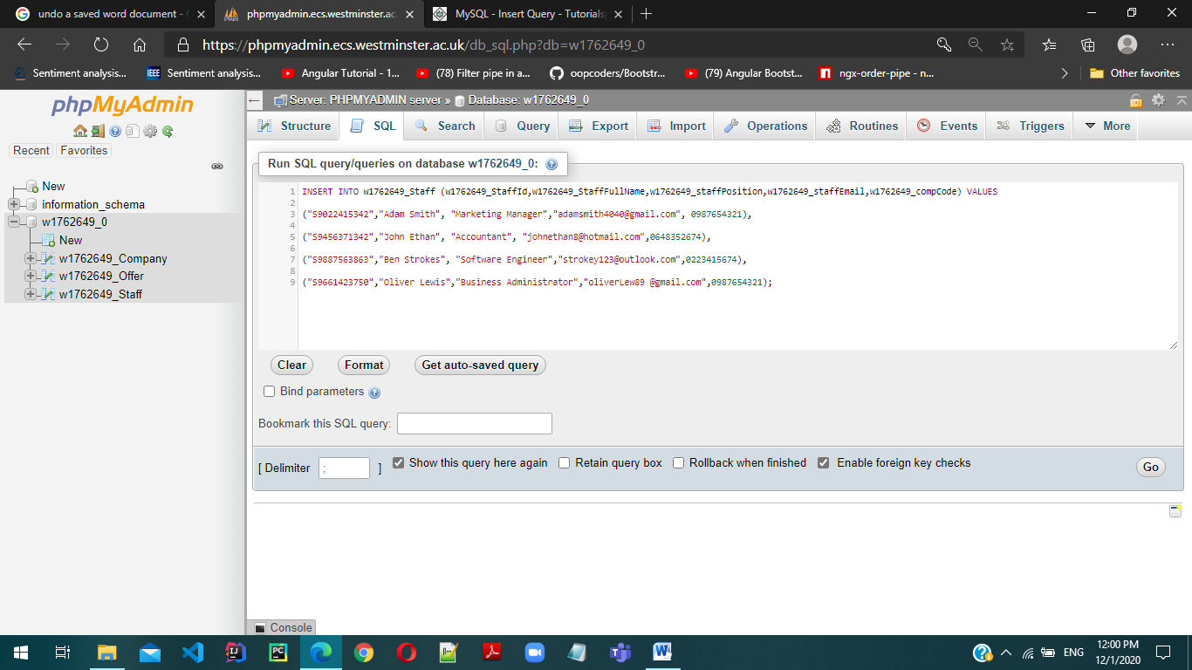

# 

**w1762649_Offer**

INSERT INTO w1762649_Offer (w1762649_offerCode, w1762649_offerName, w1762649_offerDescrip, w1762649_offerDeadline, w1762649_offerStartDate, w1762649_compCode) VALUES

(1556241395,"Pro-Student offer","Pro-Student offer free courses apart from engaging in their job works.","2020-11-21 13:23:44","2020-07-18",0223415674),

(1784563902,"Raffle Referral Bonus","Raffle Referral bonus is a raffle draw which is selected out of best five projects done which are given.","2020-10-18 5:46:21", "2020-05-11",0987654321),

(1675437891, "Overseas-Job offer","Students have an opportunity to get abroad for job experience","2020-06-09 11:12:24","2020-02-03",0648352674),

(1856211395,"Winning Prize","Students have a advantage to win a globally recognized certificate apart from their academic qualifications.","2020-12-15 14:20:59","2020-02-12",0987654321),

(1987056732,"Code run","Code run is huge offer to program using java, python or c# to enter to a recognized company in the world.","2020-03-29 16:30:59","2020-01-22",0648352674);

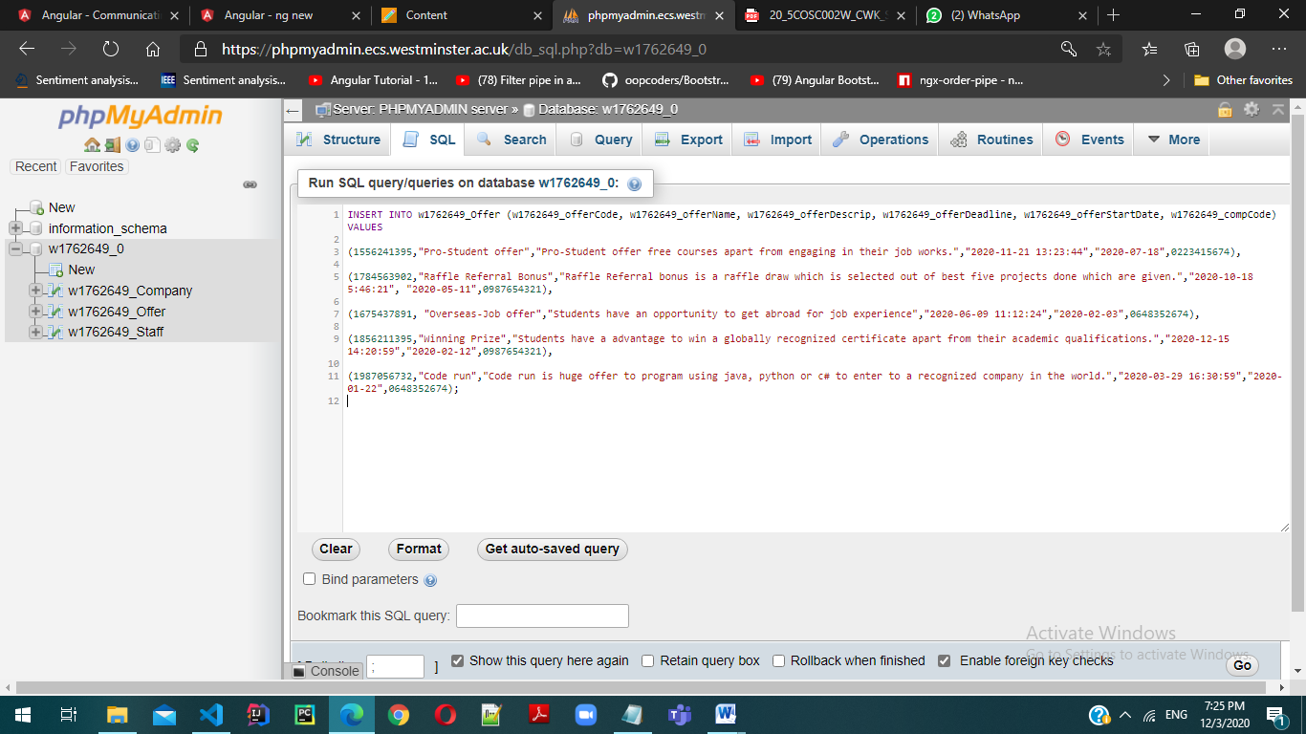

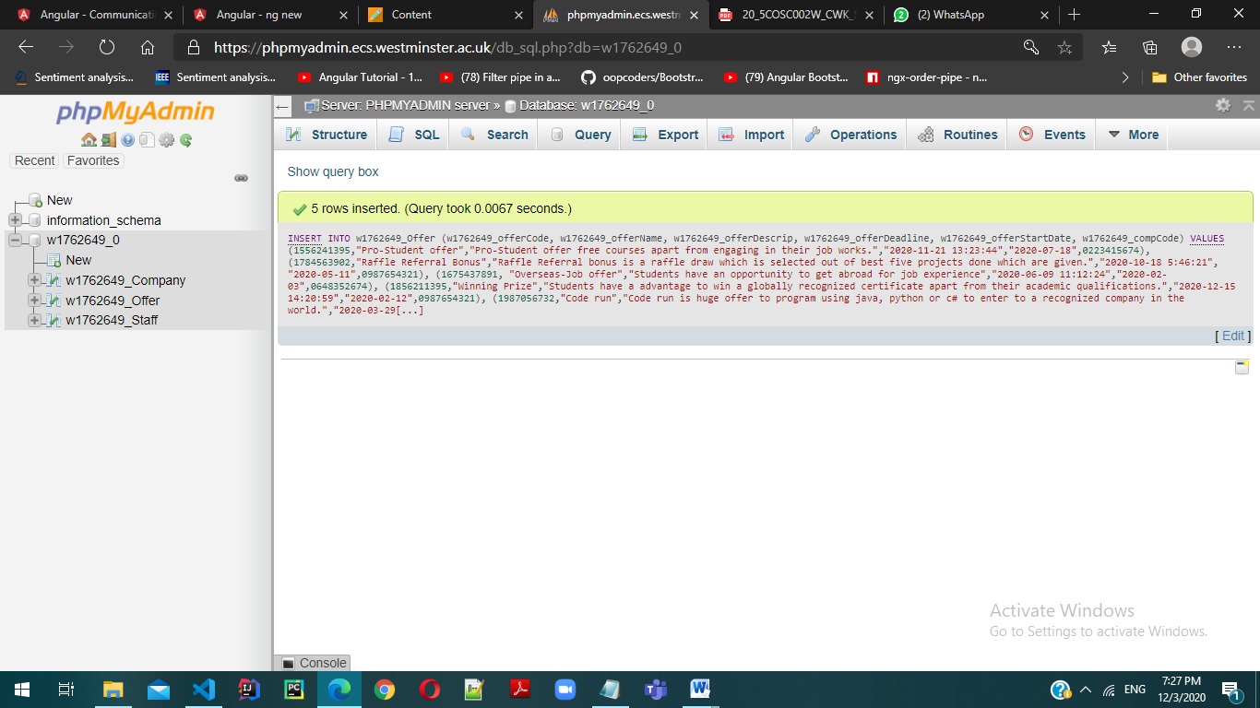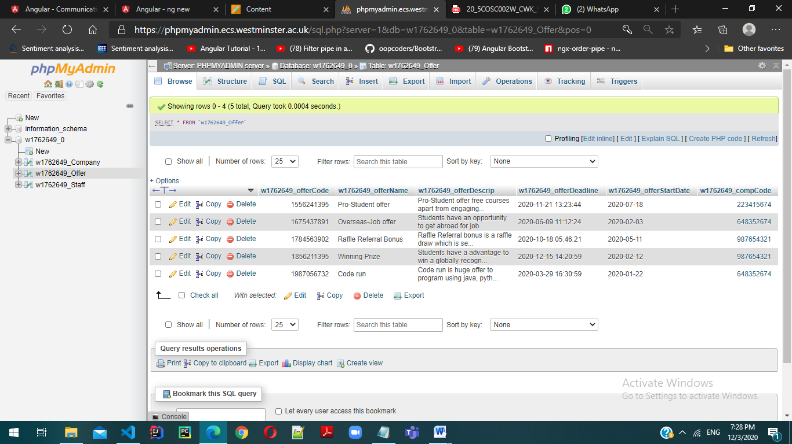

# 8) **Write a SQL query to retrieve a list of company codes and company names and for each company the number of staff that they employ, making sure that the header shows the number of employees in each company as “Number of staff”.**

SELECT w1762649_Company.w1762649_compCode,w1762649_Company.w1762649_compName,count(w1762649_Staff.w1762649_staffFullName) AS "Number of Staff"

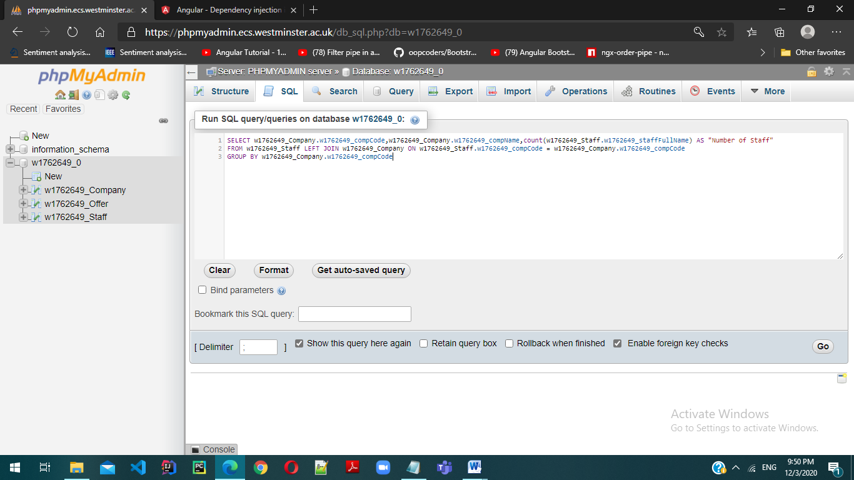FROM w1762649_Staff LEFT JOIN w1762649_Company ON w1762649_Staff.w1762649_compCode = w1762649_Company.w1762649_compCode

GROUP BY w1762649_Company.w1762649_compCode

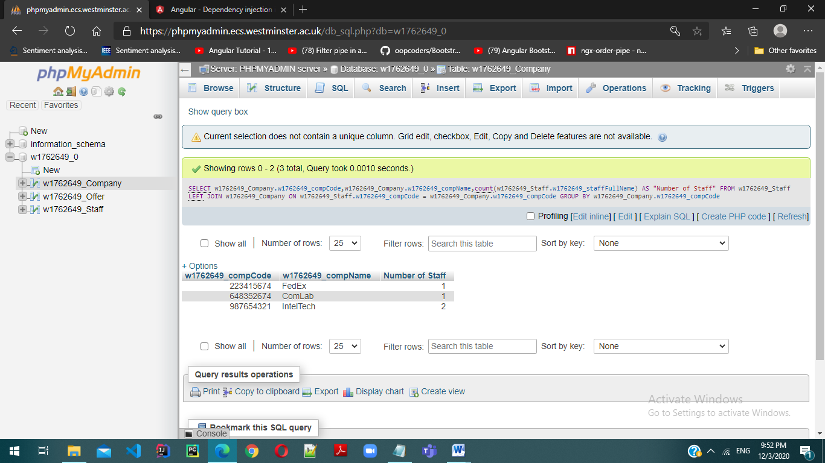

# 9) **Write a SQL query that displays a list of company names along the names and positions of staff they employ and the names and descriptions of the offers they propose.**

SELECT c.w1762649_compName,s.w1762649_staffFullName,s.w1762649_staffPosition,o.w1762649_offerName,o.w1762649_offerDescrip

FROM w1762649_Company c

JOIN w1762649_Staff s

ON c.w1762649_compCode = s.w1762649_compCode

JOIN w1762649_Offer o

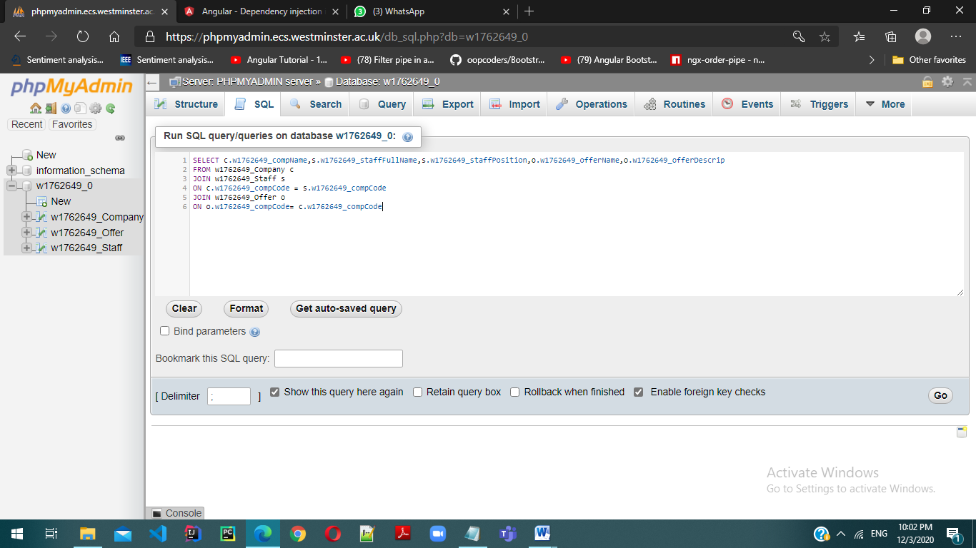ON o.w1762649_compCode= c.w1762649_compCode

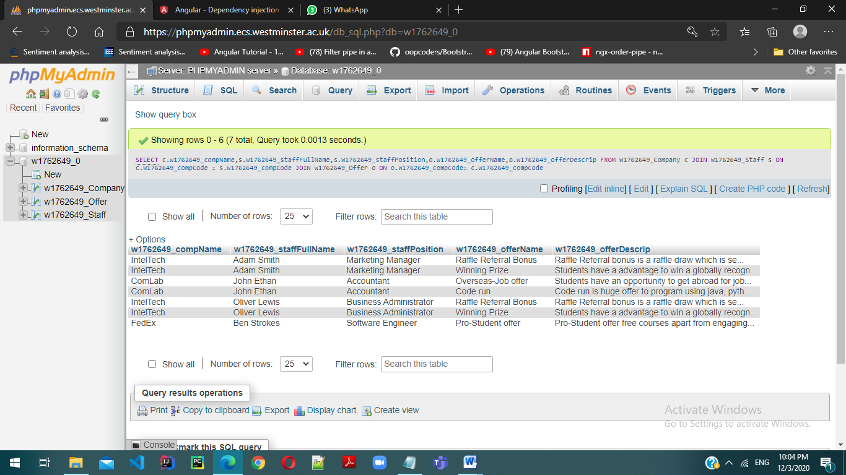

# Conclusion

As this is an individual coursework (Part A), it helps to clearly learn about the conceptual ER diagram in a further manner. Using sub classes and super classes helps to further elaborate the scenario given. Usefulness and how to apply data dictionaries in a workplace is learnt from this coursework. Data dictionaries help to clearly clarify about the entities, attributes, primary keys, subclasses and super classes and why those were identified as the entities, attributes, primary keys, subclasses and super classes. And also when considering the Part B, it helps to map a logical ERD to a given conceptual ERD, to create SQL queries and the related works on SQL.

# References

* W3schools.com. 2020. *Java Inheritance (Subclass And Superclass)*. [online] Available at: <https://www.w3schools.com/java/java_inheritance.asp> [Accessed 14 October 2020].
* Tutorialspoint.com. 2020. *What Is Data Dictionary*. [online] Available at: <https://www.tutorialspoint.com/What-is-Data-Dictionary> [Accessed 14 October 2020].
* Dl.ebooksworld.ir. 2020. [online] Available at: <https://dl.ebooksworld.ir/motoman/Pearson.Database.Systems.A.Practical.Approach.to.Design.Implementation.and.Management.6th.Global.Edition.www.EBooksWorld.ir.pdf> [Accessed 14 October 2020].